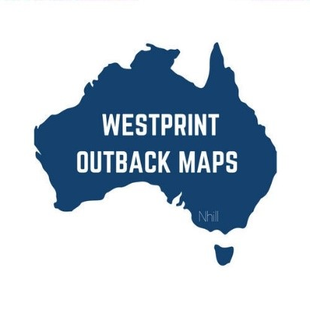****

**The Meridian Line - Sunday 03.09.2023**

* ***"*Remember that happiness is a way of travel, not a destination.”**

***Unknown***

**List a product.**

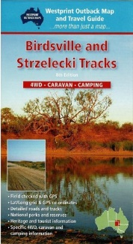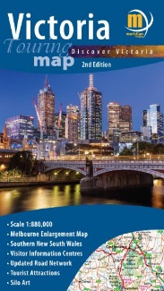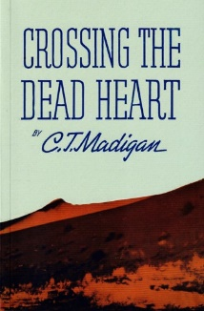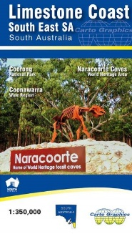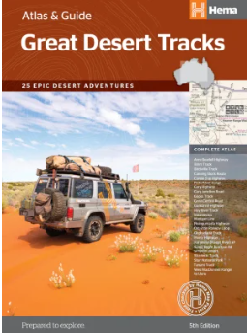

***Victoria Touring Map – from $12.95***

This 1:880,000 scale touring map of Victoria, features a comprehensive display of the State's top tourist destinations, parks, forests, campgrounds, and points of interest with clear markings. This map boasts exciting additions such as the Silo Art Trail, wine regions, ski resorts, visitor information centers, and much more. Its user-friendly design ensures easy readability, making it the perfect companion for exploring Victoria.

On the reverse side of the map, you'll find a detailed map of Melbourne and its surrounding areas, allowing you to navigate the city with ease. Moreover, there's a helpful index listing all Victorian locations, ensuring you can swiftly locate your desired destinations. Whether you're embarking on a journey for pleasure or business, this map provides everything you need to make your trip in Victoria a memorable and enjoyable experience.

<https://meridianmaps.com.au/product/victoria-touring-map/>

***Birdsville and Strzelecki Tracks – $14.95***

The Birdsville and Strzelecki Tracks are iconic outback routes in Australia, known for their remote and adventurous nature.

The Birdsville Track is a historic stock route that stretches over 500 kilometres from Marree in South Australia to Birdsville in Queensland. It traverses through vast desert landscapes, crossing the Sturt Stony Desert and the Simpson Desert. The track's significance lies in its historical use for cattle droving and its role in the Birdsville Races, an annual event attracting visitors from far and wide.

The Strzelecki Track spans approximately 475 kilometres, connecting Lyndhurst in South Australia to Innamincka in the northeastern part of the state. Both tracks offer travellers a chance to experience the rugged beauty of the Australian outback, encounter unique flora and fauna, and explore the rich cultural heritage of the region.

<https://meridianmaps.com.au/product/birdsville-track/>

***Crossing the Dead Heart – $14.95***

Written by C.T. Madigab, "Crossing the Dead Heart" is a captivating account of a remarkable expedition undertaken in 1939 with the purpose of traversing an unexplored region in the Northern Territory of Australia. The ambitious journey was made possible through the financial support of Mr. A.A. Simpson, the namesake of the desert they ventured into.

Starting from Charlotte Waters on the border between South Australia and the Northern Territory, the expedition progressed beyond Andado bore and bravely crossed the arid expanse of the desert to reach Birdsville in Queensland. From there, they turned southwest and reached the shores of Lake Eyre, eventually reconnecting with the railway at Maree.

"Crossing the Dead Heart" is a story of immense courage, perseverance, and scientific curiosity, and it stands as a testament to the audacity of those who dare to venture into the unknown in the pursuit of knowledge and discovery.

<https://meridianmaps.com.au/product/crossing-dead-heart/>

***Limestone Coast South East SA – from $9.95.***

*A detailed touring map, at a scale of 1:350,000, detailing the south east corner of South Australia. It showcases* major and minor roads, national parks and conservation reserves, significant campgrounds, and cellar doors. Includes a detailed inset map of the Coonawarra Wine Region with cellar door locations.

<https://meridianmaps.com.au/product/limestone-coast-map/>

***Great Desert Tracks Atlas & Guide – $69.95***

Embark on an adventurous journey through Australia's desert regions with this comprehensive guidebook! Whether you're a passionate 'desert lover' or simply eager to explore some of the country's favourite 4WD destinations, this informative guide is an indispensable companion for traversing the arid centre of Australia.

This edition boasts handy track profiles, displaying elevations and distances, along with points of interest, camping areas, and supply points all presented in easy-to-follow graphics. Navigating through the desert is made seamless with a convenient atlas containing maps and detailed inset maps.

There are 25 featured 4WD trips with tracks coded by vehicle type and towing suitability symbols. Roads and tracks have been GPS-surveyed, displaying fuel and provision availability to aid in your planning. Track descriptions include permit information and contact details, information on major environments, ecosystems, and historical context.

<https://meridianmaps.com.au/product/great-desert-tracks/>

**Meridian Musings**

We received some feedback on our reader’s story on Reedy name places from last fortnight’s newsletter.

“Your mention of the numerous places with Reed or Reedy in their name reminded me of an evening long ago when I was poring over my collection of inch to the mile maps of NSW. Almost everyone contained a Sugarloaf Hill or Mountain and a Breakfast Creek. Dinner Creek was not too far behind.

More recently, while making trips to the Little River Gorge (note the unusual name) I found Turnback Track, Seldom Seen Track, Slippery Pinch Road,  Pleurisy Plains, Worlds End Spur. Tough country!”

These names certainly make you think who is responsible for naming places or what they use as their motivation for naming them!

Not sure how many of you had the chance to watch the new series on SBS – “Great Australian Walks with Julia Zemiro”. The first episode focussed on Point Nepean which is on the Mornington Peninsula in Victoria while the second featured Dorrigo National Park in NSW. These two walks are totally different – one has a rugged coastal landscape whilst the other is a sub tropical rainforest. Meanwhile, the Great South West Walk, in south west Victoria, was the subject of a recent edition of Back Roads on the ABC. Watching these shows makes me think of all the amazing walks that we have done whilst out and about in our beautiful country as well as the hours we have spent driving around while we field check for our bush walking and four wheel drive maps.

There are so many short walks to enjoy or if you prefer, day or multi day hikes. There really is something for every age and every fitness level, it’s just a matter of planning and getting out there.

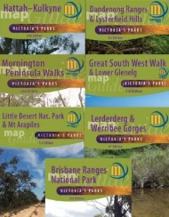

.

<https://meridianmaps.com.au/product-category/walking-park-maps/>

If you are an avid bushwalker or a member of a bushwalking club and would like to share a story, drop a line to [rochelle@meridianmaps.com.au](mailto:rochelle@meridianmaps.com.au).

For those planning to head out outback South Australia, please make sure you check out the latest information from Parks South Australia. Road access and conditions continually change and it is important to check up to date conditions before you leave. There is also a warning from South Australia health is relation to mosquitoes as they can be active around water bodies in northern South Australia. They are not only a nuisance, but some can spread disease so make sure you cover up and apply appropriate insect repellent. For further up to date information check out the latest desert park bulletin.

[https:// www.parks.sa.gov.au/know-before-you-go/desert-parks-bulletin](https://www.parks.sa.gov.au/know-before-you-go/desert-parks-bulletin)

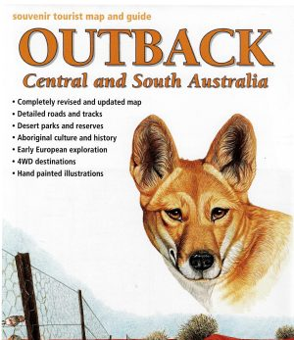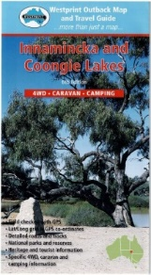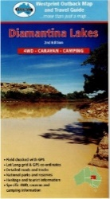

<https://meridianmaps.com.au/product-category/westprint/>

**Goog’s Track is about to turn 50 years old!**

In 1973, an Australian farmer by the name of John ‘Goog’ Denton came up with the idea to cut a track directly north from his cattle station in South Australia towards the middle of Australia through rough Aussie scrub and sand dunes. In 2023, fifty years later the original unmaintained single track remains as a route through the scrubby bush. Today, Goog’s Track is a 4WD track located in South Australia, running from Ceduna to Kingoonya, with a distance of approximately 500km. On the 16th of September, the Denton family in conjunction with local national parks will host a day of celebrations at Googs Lake.

For further information or to book your place, go to <https://www.facebook.com/photo/?fbid=10160955065008987&set=g.862677363802779>.

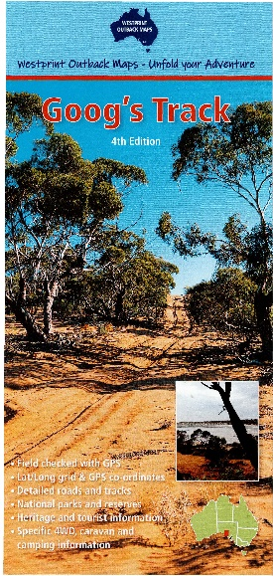

<https://meridianmaps.com.au/product/googs-track/>

Here's a chance to get out in the beautiful Dandenong Ranges and participate in STEPtember Park Walks run by Parks Victoria. STEPtember is a wellness challenge in support of cerebral palsy although you do not have to be part of the challenge to join the Dandenong Park Walks. For more information contact nita.mcintyre@parks.vic.gov.au or dale.walker@cerebralpalsy.org.au.

Walks will be held on Thursday 7, 14, 21 and 28 September.

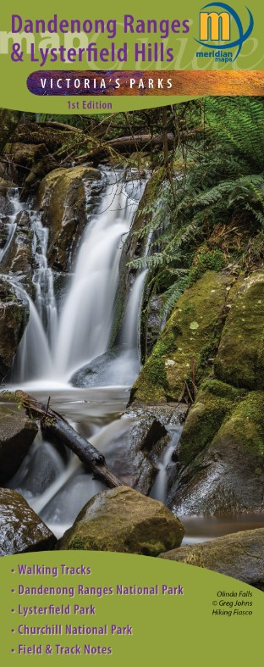

<https://meridianmaps.com.au/product/dandenong-ranges-map-guide/>

*Disclaimer: These events were correct at the time they were added to the Meridian Line; however, this may have been some time before the actual event. Please make your own enquiries before travelling to an event.*

**Reader’s Stories**

Many thanks to one of our regular readers and contributors for this fascinating insight into the town of Onslow in Western Australia,

**(Old) Onslow**

The town is on the Pilbara coast of Western Australia, between Exmouth and Karratha, and 82kms west of the North West Coastal Highway. The present town of Onslow has only existed since 10 January 1924 when it was gazetted. However, before that, another town named Onslow existed 11kms south-west at the mouth of the Ashburton River. It was named after the Chief Justice of Western Australia, at the time, Sir Alexander Onslow. When William Dampier landed near the area in 1699, he described it as: “Forbidding, barren land where nothing grows. Water is almost non-existent, and the few natives seen are poor primitives…”.

The first settler in the area was James Clark who established a store at the mouth of the Ashburton River. He had been the chief engineer of the schooner “Rob Roy” when it ran aground at the mouth of the Ashburton in 1881. He could see many possibilities for the future there and later moved to the area with his wife and eldest son, and built a store: Clark & Co., agents for shipping and customs, in 1883. Clark also built a jetty, and later built the “Rob Roy Hotel” in Onslow. Shortly after, Clarks’ brother, Harry, and brother-in-law John McKenzie and their families, also settled in the town.

In 1885 the Government Surveyor, Thomas Beasley, surveyed the town, and officially gazetted it. Later that year the town was connected to the overland telegraph. In 1893 the police station and court house were completed.

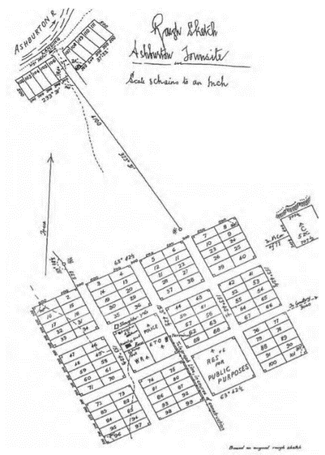

*Original Onslow townsite plan*

The town had an extremely variable weather pattern. It experienced severe cyclones in 1883, 1909, 1918, and 1926, interspersed with long periods of drought. The drought of 1891 was so severe that many pastoralists walked off their land never to return. During the drought of 1911-1915 the town received only 14.5mm of rain for the whole of 1912. It wasn’t only drought and cyclones that made life harsh for the residents of Onslow. Strong winds causing sand storms, mosquitos, flies, and other insects, and water shortages, all contributed to life being extremely difficult. Despite these problems the town continued to grow.

The provision of medical services was a problem right from the start. But with the appointment of the first doctor in 1893, the situation improved, slightly. There was no hospital, and the doctor had to work from his home. Consequently, doctors rarely stayed for very long. The problem was partly solved in 1896 when the first magistrate was appointed; he was also required to be a licensed doctor. Things improved, slightly, for the doctor/magistrate in 1897 when the hospital was completed.

With a largely itinerant population, child education was never a priority in Onslow. Any education that was required was carried-out by the Anglican minister after the church hall was completed in 1904. However, this was destroyed by a cyclone in 1909, and was not re-built. But seeing the need for a community hall, the population banded together and constructed a Mechanics Institute in 1912.

This building was then used as the church, school, meeting hall, and social gathering point. An air mail service was introduced in 1921. The residents were convinced that this was a town with a bright future.

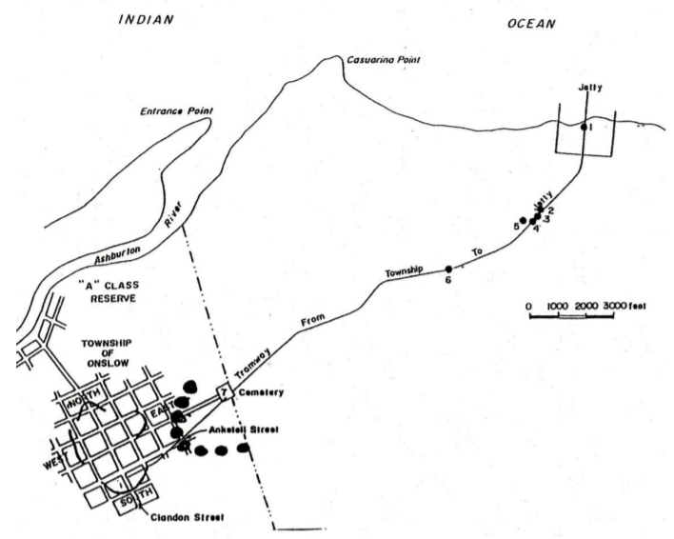

*Map of Old Onslow, undated.*

As the mouth of the Ashburton gradually silted-up, a new jetty was built north of the town and the cargo transferred by a horse-tram 6kms between the jetty and the town. However, the shore around the new jetty also trapped the silt, making it, eventually, impossible for the ships to dock. This made it necessary for lighters to be used to transfer the cargo form the ship to the jetty.

During the Great War, there was an increased demand for the wool and beef produced around the Ashburton. Consequently, more ships needed to be loaded, but the use of lighters slowed the process considerably. This prompted discussion on moving the town to a more suitable location. This did not sit well with the original inhabitants; they had built-up their businesses and invested substantial amounts of money in the future of the town. They proposed an alternative; build a new jetty at Parkes Reef out into the open ocean where it would not be affected by silt or tides. However, this would require a bridge to be built over the Ashburton River, and most residents saw this as moving the problem from one place to another.

Eventually the state government acted and decided to move the town to Beadon Point, 11kms north-east. As most of the buildings in the town were constructed of timber, they would be easy to move. The town was gazetted in 1924, and gradually over the next few years, most movable buildings were dismantled, loaded onto wagons, and pulled by camels to the new townsite. A new timber and concrete jetty, 1½kms, long was constructed out into the ocean from the tip of Beadon Point. However, the storage sheds that had been relocated from Old Onslow, were built well inland, at the eastern end of town. To connect the two, a tramway was laid down the middle of the main street.

The jetty was damaged by successive cyclones over many years. Eventually, it was decided to relocate the Port of Onslow to Beadon Creek. The waterway was widened and deepened, and a new wharf built on the western shore.

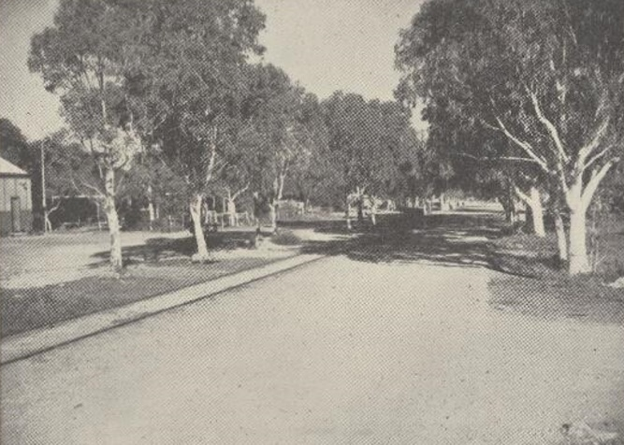

*The main street of Onslow, Second Avenue, looking east. The tram lines run from the jetty to the sheds, the site of the present visitor centre. The trees are still there. Photo taken approx. 1950, Walkabout magazine.*

The other decision to be made, and which divided the population, was what to call the new town. The main contenders were “Beadon”, mainly favoured by the government, and “Ashburton”, favoured by many residents. However, everyone, eventually, became resigned to keeping the name of “Onslow”.

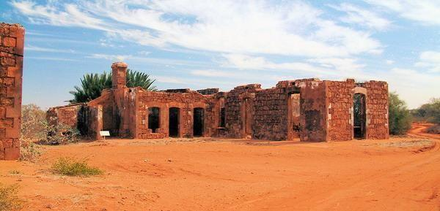

*The ruins of the Old Onslow police station and jail.*

Old Onslow today is a collection of the original, mainly government, stone buildings, including the police station and jail, court house, post office, and Rob Roy Hotel. Scattered throughout the townsite are piles of empty bottles.

However, the new town of Onslow is a complete contrast. To encourage the residents to move to the new town, the government allowed them to choose their own block of land at no cost. Some chose not to move; the owners of the Ashburton Hotel sold all their possessions and left the area for good.

The visitor centre and museum are housed in one of the original storage sheds that was transported from Old Onslow. The main recreational activity is fishing, either from the wharf in Beadon Creek, off-shore boats, or on Mackerel Islands. The ANZAC Day dawn service is like no other in Australia. The memorial is sited so the sun rises through the memorial, creating a stunning sight.

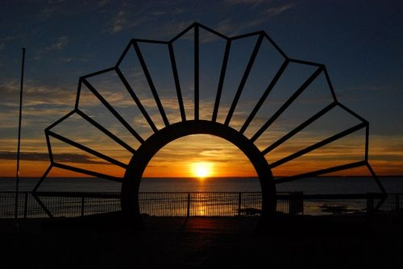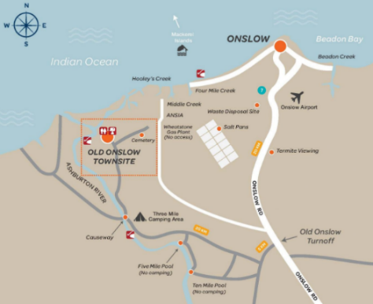

Onslow has the most spectacular ANZAC Map of the Onslow area cropped from the

war memorial in Australia. Shire of Ashburton’s Onslow regional Map.

Many thanks for the Onslow article. The list of references is extensive. If you would like them, please email me [rochelle@meridianmaps.com.au](mailto:rochelle@meridianmaps.com.au) and I will send them to you.

**Meridian Mirth**

In celebration of Father’s Day this week, thought I would include some classic dad jokes. I apologise in advance!!

There’s a big difference between bad jokes and dad jokes. And that difference is the first letter.

Why do fathers take an extra pair of socks when they go golfing?" "In case they get a hole in one!

Two eggs, a bagel, and a sausage walk into a bar. “Bartender, my friends and I would like a cold one,” says one of the eggs.

“Sorry,” the barman replies. “We don’t serve breakfast.”

I'll call you later. "Don't call me later, call me Dad."

My manager told me to have a good day. So, I didn't go into work.

What did the boy say to his fingers? I'm counting on you.

Why do spiders know everything? They get their information from the Web.

Dad, did you get a haircut? No, I got them all cut.

What did the slow tomato say to the others? Don't worry; I'll ketchup.

Every night we sit at the table to have dinner, hubby says, “Hey, guess who I saw today.” The kids always say, "Who?" Hubby says, "Everyone I looked at.”

Why didn’t the skeleton cross the road? He didn’t have the guts.

The day I turned 42, my daughter walked up to me and said, "Happy...," and started timing on her watch. After a long silence she said, "...40-second birthday." I was so proud.

You are welcome to use information from this newsletter, but we request that you kindly acknowledge that the information is from The Meridian Line.

**About the Meridian Line**

Wherever possible we try to acknowledge the source of all information contained in this newsletter. We offer no guarantees for accuracy, but we do our best.

**Using information from this newsletter**

You are welcome to use information from this newsletter, but we request that you kindly acknowledge that the information is from The Meridian Line.

**Get the Word Out**

Feel free to forward this newsletter to any family or friends who you feel might enjoy a good read. If they would like to receive this newsletter on a regular basis please drop us a line at [rochelle@meridianmaps.com.au](mailto:rochelle@meridianmaps.com.au)

**Meridian Contact information -** Email: rochelle@meridianmaps.com.au

**Disclaimer -** Please note that the opinions and articles expressed in The Meridian Line are not necessarily those of the Meridian team. Also, we do not endorse any products (other than our own), or tours listed in any contributed articles.