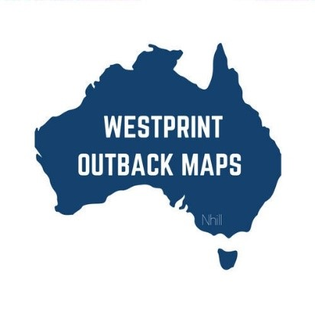****

**The Meridian Line - Friday 15.09.2023**

***"Adventure is out there” – Charles Muntz***

**List a product.**

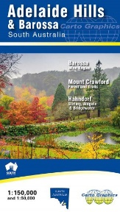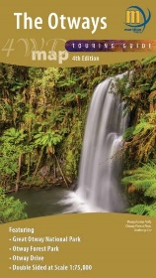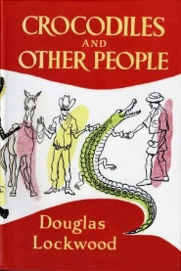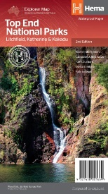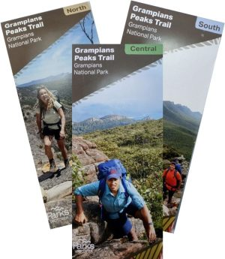

***Otways 4WD Map – from $14.95***

A double-sided 4WD map at the new scale of 1:75,000 encompasses the vast expanse of the Otway Ranges, stretching from Anglesea to Princetown. This detailed map showcases an array of roads and tracks, along with designations for waterfalls and tourist amenities. Notably featured are prominent attractions like the Great Ocean Walk, Rail Trails, and the Otway Drive, all presented with utmost clarity. Crafted to cater to both 4-wheel driving enthusiasts and vacationers, this map serves as an ideal companion for touring.

<https://meridianmaps.com.au/product/the-otways-4wd-map/>

***Adelaide Hills and Barossa Valley Map – from $9.95***

The Adelaide Hills & Barossa Map has a scale of 1:150,000, spanning Strathalbyn to Kapunda, Adelaide to Murray Bridge. This map showcases roads, road names, parks, and cellar doors, while offering elevation shading. Notably, it displays long-distance trails like Heysen, Mawson, Kidman, and Lavender Federation. A 1:50,000 inset map zooms into Crafers to Hahndorf, while the reverse side features a 1:75,000-scale Barossa Wine Region map and a 1:50,000-scale topographic map of Mount Crawford Forest. An index aids in locating towns, parks, reserves, and wineries.

<https://meridianmaps.com.au/product/adelaide-hills-barossa-map/>

***Crocodiles and Other People – $34.95***

Enclosed within these narratives are tales of Aboriginal corroborees, Japanese pearl divers, overlanding expeditions, and uranium mining ventures. Among them, you'll encounter the peculiar anecdote of a wallaby turned assailant, and the astonishing chronicle of a crocodile that took residence in the confines of the Commercial Bank. These stories traverse the spectrum of human emotions, ranging from amusement to horror, and even disbelief – were it not for the credibility upheld by Douglas Lockwood, who remains staunchly averse to being categorized among the easily convinced.

<https://meridianmaps.com.au/product/crocodiles-other-people/>

***Top Ends National Parks – from $14.95.***

This is a comprehensive regional map encompassing Litchfield (1:160,000), Katherine Gorge, and Kakadu (1:350,000) national parks. This map also incorporates a detailed map of the Darwin region (1:850,000), enriched with an abundance of tourist insights. Encompassing the area from the Arnhem Highway to Kakadu, the Mary River, Stuart Highway to Katherine, Litchfield National Park, Katherine Gorge (Nitmiluk) National Park, and Kakadu National Park. Listings of national park facilities, offering essential information, accommodation options and visitor centre contact details for the region are also provided.

<https://meridianmaps.com.au/product/top-end-parks/>

***Grampians Peaks Trail South, Central and North– From $9.95 each***

The Grampians Peak Trail is Victoria’s newest long-distance trail. Established by Parks Victoria, the trail starts in the north of the Grampians at Mt Zero and finishes 164kms later in Dunkeld. Designed as a 12 -13 day trip, it can be done in sections. There are three maps in the Peak trail series. Maps can be purchased individually or as a set. Also available laminated to withstand the constant folding and unfolding.

The southern section at 1:50,000 extends from Jimmy Creek Road to Dunkeld.

The central section at 1:50,000 from Halls Gap to Yarram Gap Road.

The northern section at 1:50,000 from Mt Zero to Halls Gap.

[***https://meridianmaps.com.au/product/grampians-peak-trail-south/***](https://meridianmaps.com.au/product/grampians-peak-trail-south/)

[***https://meridianmaps.com.au/product/grampians-peak-trail-central/***](https://meridianmaps.com.au/product/grampians-peak-trail-central/)

[***https://meridianmaps.com.au/product/grampians-peak-trail-north/***](https://meridianmaps.com.au/product/grampians-peak-trail-north/)

**Meridian Musings**

Personally, I am always much happier as we get further into Spring and the weather starts warming up that bit more. There is so much more temptation to get out and about and there are certainly more organised events to join. We just enjoyed a lovey weekend in the Daylesford area and whilst there, had an opportunity to do some beautiful walks and drives in both the Wombat State Forest and Lerderderg State Park. The falls in the area were running and the flowers were blooming – absolutely worth a visit.

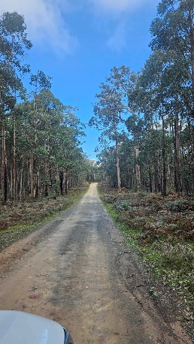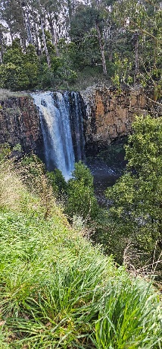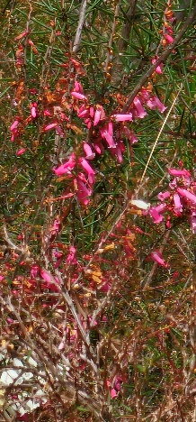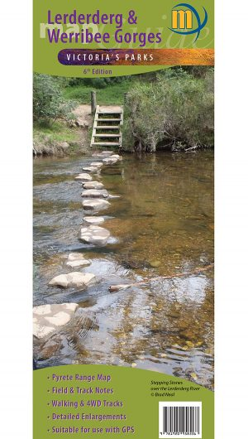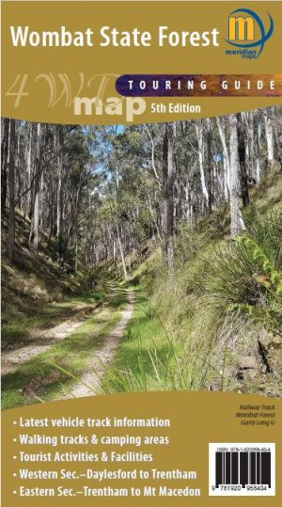

What’s on:

If running is your idea of fun, consider the Roller Coaster Fun Run in the Dandenong Ranges on the weekend of October 28/29. The Roller Coaster Run is Melbourne’s mountain run and all about the zig-zag tracks, the gnarly loops and the trails that never flatten out in the lush, wilderness of the Dandenong Ranges National Park. <https://rollercoasterrun.com/>.

Personally, I prefer walking! Here’s a chance to walk and enjoy spectacular scenery whilst raising vital funds to help find cures for mitochondrial disease! The Bloody Long Walk on the Mornington Peninsula is a 35km challenge on 15 October from Point Nepean National Park to Martha Cove.

Head to the Naracoorte Caves in the Naracoorte Caves National Park on October 6 for a nature walk around the national park. Learn how to identify different plants and animals from evidence we can find and learn how important biodiversity is to the health of our environment. <https://events.humanitix.com/connecting-to-the-nature-in-naracoorte-caves-national-park>

The Winton Outback Festival in Outback Queensland is Australia's most unique festival offering five days of exciting activities. <https://10times.com/outback-festival>

*Disclaimer: These events were correct at the time they were added to the Meridian Line; however, this may have been some time before the actual event. Please make your own enquiries before travelling to an event.*

**What’s in the Not Quite Right Area**

The stock in the not quite right laminate tab is being constantly updated. There are never many of any particular map available and once they are gone, they are removed from the website. It really is first in, best dressed with these special offers.

Maps currently available include:

* Great South West Walk & Lower Glenelg
* Birdsville and Strzelecki Tracks
* Grampians Peak Trail South Map
* Australia Wall Map

<https://meridianmaps.com.au/product-category/not-quite_right_maps/>

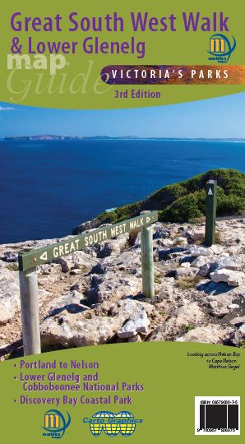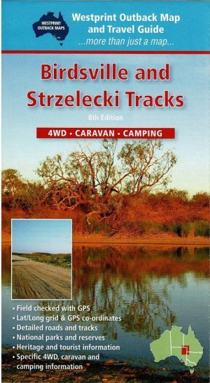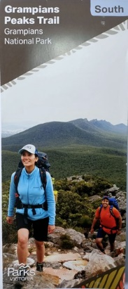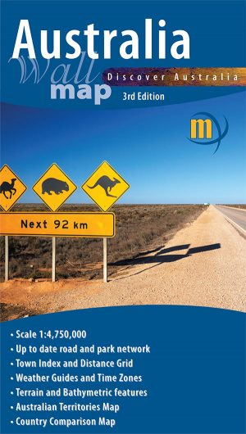

**Reader’s Stories**

Many thanks to one of our readers for recounting this bizarre meeting he had while travelling along the Tanami track a few years back. If you have had an exciting experience whilst out and about, we would love to hear it. Just email the Meridian Line at [rochelle@meridianmaps.com.au](mailto:rochelle@meridianmaps.com.au).

**Strange Encounters on the Tanami Track**

It was 1988, and my workmate Ben and I were on one of my excursions around Australia. Leaving Alice Springs , there is a 1040km “short cut” to the Kimberleys in Western Australia via the Tanami Track, past the aboriginal settlement of Yuendumu and the lonely roadhouse of Rabbit Flat approximately 600km Distant. The present Tilmouth Well Roadhouse didn’t exist in those days.

Shortly before reaching Yuendemu we encountered the first strange incident. Up ahead an old Holden car was parked sideways across the road with the bonnet up and surrounded by a few aborigines. We approached slowly in case they needed help but we were waved on. Glancing back, we noted that the car didn’t have an engine. Perhaps they were waiting for the RAA to bring them a new engine!

About 100km east of Rabbit Flat we could see in the distance another car parked on the side of the road with the bonnet up and from its confined stepped a man who walked into the middle of the road and flagged us down.

I approached cautiously and as we got closer his presence prompted both of us both to lock our doors. He was a giant of a man with a mop of bushy unkempt hair and a thick beard just as bad. This wasn’t the only reason that I only wound my window down a shortway as he was dressed in army camouflage and shirt and trousers were ripped to pieces and looked like he had been in a fight with a tiger (for that reason Ben and I refer to him as the tiger man when reminiscing). He said he was broken down and could we take him to Alice Springs. We couldn’t have taken him if we wanted to as my short wheelbase Nissan Patrol was packed to the roof with all our gear for a couple of months on the road. We told him he should wait for someone going his way but we could take a message to Rabbit Flat and advise people there of his plight. He said if we know someone (if we know someone????) who could take him to Alice Springs he would give them two 44 gallon drums of fuel and pointed a little way up the road to what we hadn’t yet seen, a trailer in the bush, just off the road with two 44 gallon drums on board. Before departing, we enquired as to whether he had food and water and he assured us he did but made one more request.

“Did we have any smokes?”. Unfortunately for him we didn’t smoke so he wasn’t having much luck. As we departed we were in for one more surprise. Passing by the open door of the car, an early model Range Rover, (I guess that explained all the fuel) we could see that the driver’s seat was slashed to pieces, just like his clothes. A strange encounter indeed.

***Postscript: “ We never found out what happened to that bloke.”***

**Meridian Mirth**

Great to see that our readers have a sense of humour! I have enjoyed reading the feedback that people look forward to reading the mirth section. Somewhat like always reading the “odd spot” or the comics in the newspaper first.

Enjoy these one liners which were sent in by a reader who knows how to have a good laugh! If you would like to contribute, please feel free to drop me a line: [rochelle@meridianmaps.com.au](mailto:rochelle@meridianmaps.com.au)

Two blondes walk into a building ........you'd think at least one of them would have seen it.

Phone answering machine message - '...If you want to buy marijuana, press the hash key...'

A guy walks into the psychiatrist wearing only Clingfilm for shorts. The shrink says, 'Well, I can clearly see you're nuts.'

I went to buy some camouflage trousers the other day - but I couldn't find any.

My friend drowned in a bowl of muesli. A strong currant pulled him in.

A man came round in hospital after a serious accident. He shouted, 'Doctor, doctor, I can't feel my legs!' The doctor replied, 'I know you can't, I've cut your arms off'.

I went to a seafood disco last week and pulled a muscle.

Man goes to the doctor, with a strawberry growing out of his head. Doc says 'I'll give you some cream to put on it.'

What do you call a fish with no eyes? A fsh.

'Doc I can't stop singing 'The Green, Green Grass of Home'

'That sounds like Tom Jones syndrome. '

'Is it common?'

'It's not unusual.'

A man takes his Rottweiler to the vet. 'My dog is cross-eyed, is there anything you can do for him?'

“Well,' said the vet, 'let's have a look at him'

So he picks the dog up and examines his eyes, then he checks his teeth. Finally, he says, 'I'm going to have to put him down.' 'What? Because he's cross-eyed?'

'No, because he's really heavy'

Police arrested two kids yesterday, one was drinking battery acid, and the other was eating fireworks. They charged one and let the other one off.

'You know, somebody actually complimented me on my driving today. They left a little note on the windscreen. It said, 'Parking Fine.' So that was nice.'

A man walked into the doctor's, he said, 'I've hurt my arm in several places'

The doctor said, 'Well don't go there any more'

Ireland 's worst air disaster occurred early this morning when a small two-seater Cessna plane crashed into a cemetery. Irish search and rescue workers have recovered 2826 bodies so far and expect that number to climb as digging continues into the night.

You are welcome to use information from this newsletter, but we request that you kindly acknowledge that the information is from The Meridian Line.

**Meridian Contact information -** Email: rochelle@meridianmaps.com.au

**Disclaimer -** Please note that the opinions and articles expressed in The Meridian Line are not necessarily those of the Meridian team. Also, we do not endorse any products (other than our own), or tours listed in any contributed articles.